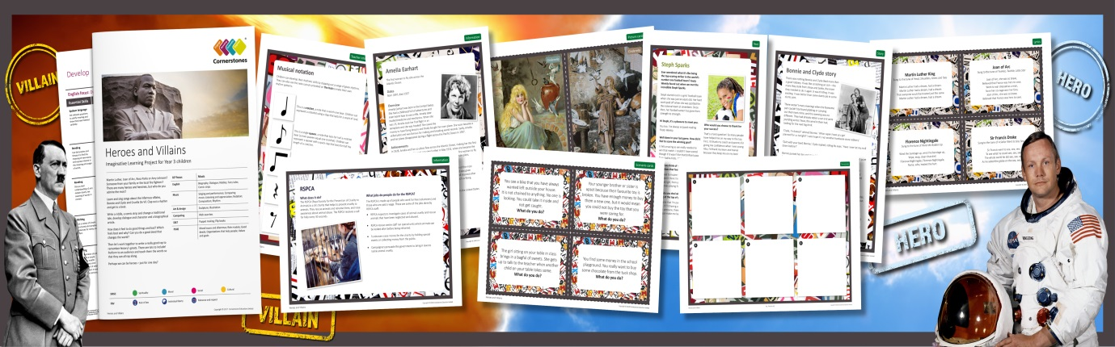
Heroes and Villains
There are so many heroes and villains in the world – who would you like to know more about? Is it someone from the past or the present? Is your hero a famous person or someone you know, like a nurse or a firefighter? This half term, we’ll meet Cruella de Vil to interrogate her about her wicked plans. Then, we’ll learn the song Cruella de Vil, make a Cruella sock puppet or flipbook animation of the story. Cruella won’t be very impressed! We’ll learn songs about the infamous Bonnie and Clyde and write dialogue for them. When we’re listening to film music, we’ll consider how sounds are used to make characters appear more villainous. Using fairy tales, we’ll examine the difference between right and wrong and write our own. We’ll also research historical heroes using a variety of source materials and put song lyrics about our favourite heroes to familiar tunes.
- English- Biographies, riddles, fairy tales, comic strips.
- Music Singing and performance, comparing music, listening and appreciation, notation, composition, rhythm.
- Art & design – illustration.
- Computing Web searches.
- D&T Puppet making, flipbooks
- PSHE Moral issues and dilemmas, role models, good deeds, organisations that help people, values and goals.
Help your child prepare for their project Heroes and villains are everywhere, in real life and fiction. Why not watch a film or read a book to identify the heroes and villains? What characteristics do they have? You could also watch CBBC Newsround and think about the heroic or villainous qualities of public figures. Alternatively, visit a museum to investigate heroes and villains throughout history.

